MCES Online sewer SurveY

How to Create user account

http://es.metc.state.mn.us/wus/ | 1) Enter the web address to access the survey.
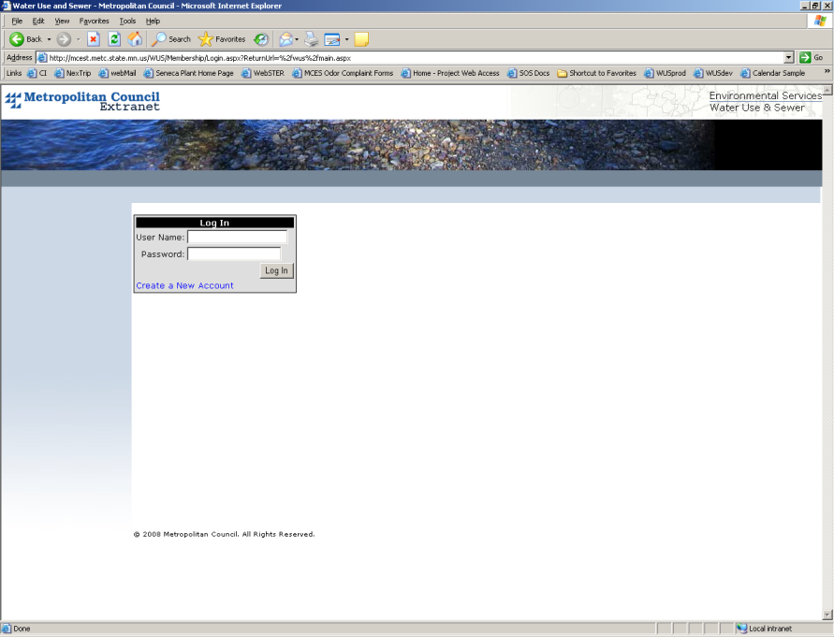 | 2) Click “Create a New Account.”
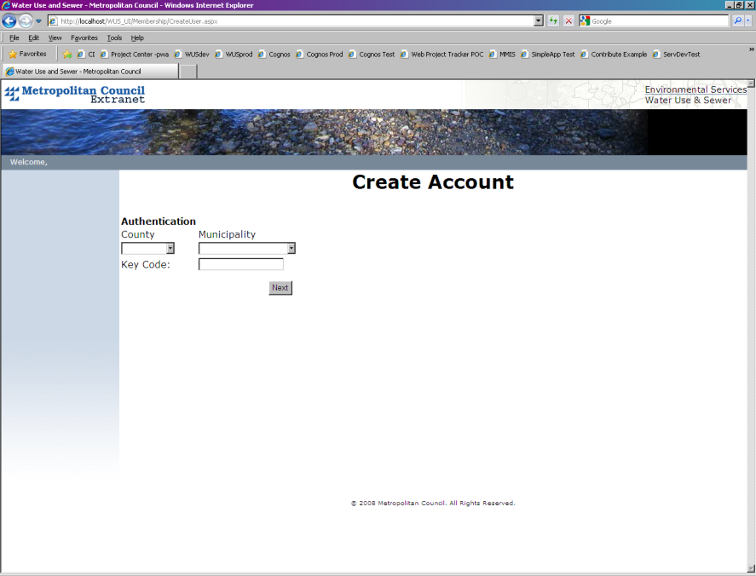 | 3) Select the county and municipality you are representing, and enter the Key Code that you received.  4) Click Next.
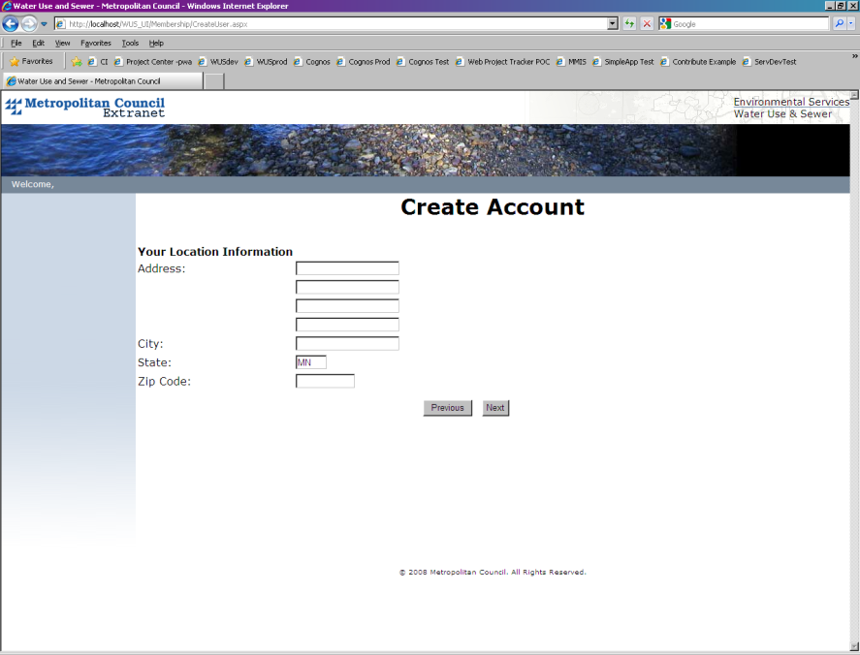 | 5) Enter your location information:  Address, City and Zip Code are required.  6) Click Next.
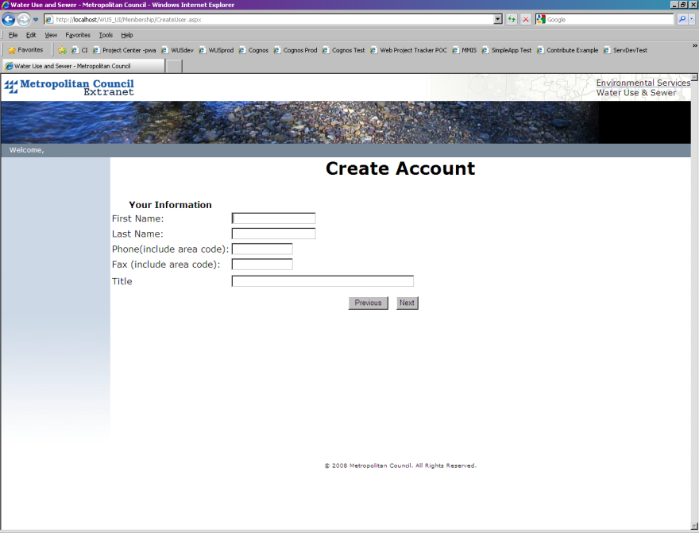 | 7) Enter your information:  First name, Last name and phone number are required. Please use dashes when listing number.  Fax number is optional. Again, please use dashes when listing number.  Title will only be requested from Authorized Agents and will be mandatory.
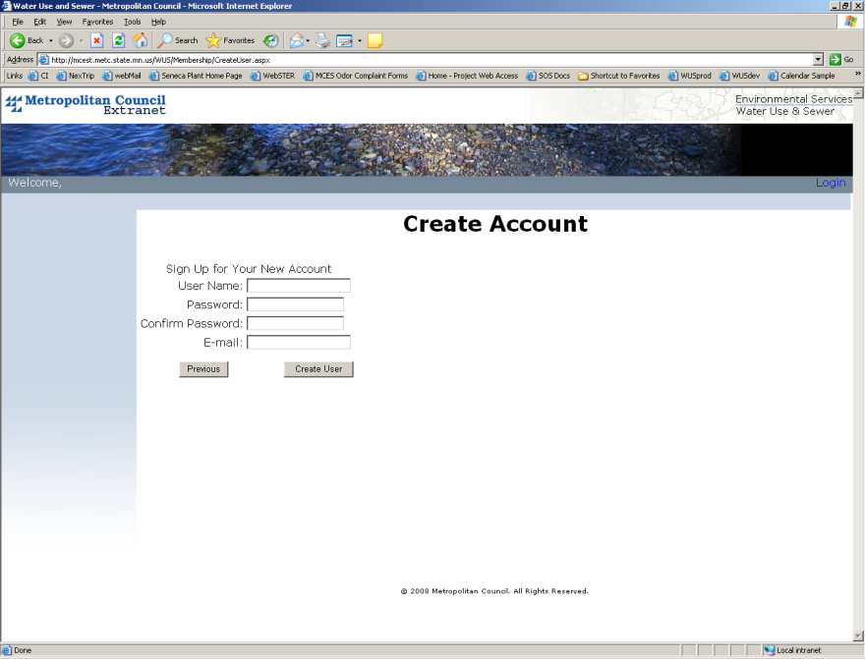 | 8) Create a unique user name and password. Do not share this information!  All fields are required.  User name criteria:  - Must be 8 characters long.  Password criteria:  - Must be 8 characters long.  - Need at least 1 upper case letter.  - Need at least 1 lower case letter.  - Need at least 1 number.  - Need at least 1 special character (e.g. #$%^!)
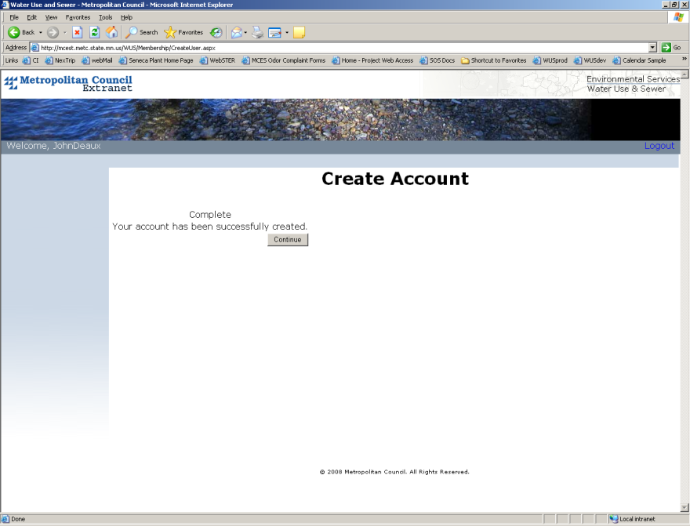 | 9) Click continue.
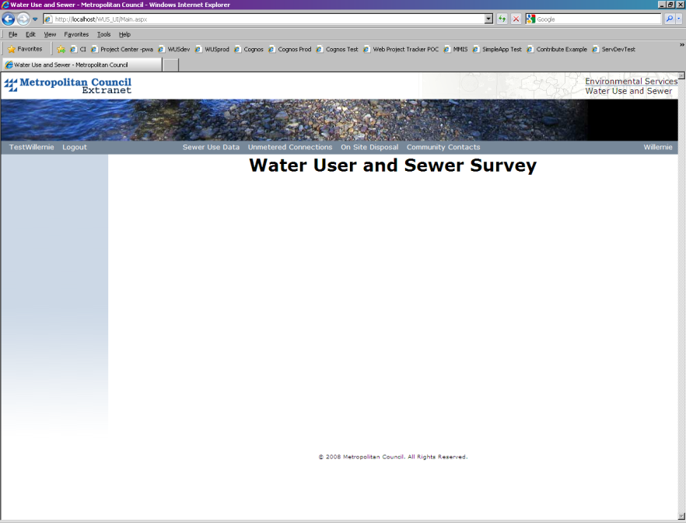 | 10) You have successfully created your account.  User name appears in the gray bar on the left.  Municipality name appears on the right side.  In the middle are the surveys that your municipality fills out.  11) To log out, click on “Logout” next to your name on the left side.

